第二周学习部小竞赛
姓名_______ 五位学号______成绩______(满分10分)
- English Crosswords（全对得4分，错1题倒扣0.2分）
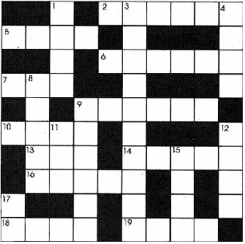
CLUES ACROSS （横）
2. Used for weighing ingredients, when cooking.
5. Vegetable similar to a pea; popular in Britain, in tomato sauce.
6. Type of fruit, often used in drinks.
7. Put this in your drink on a hot day.
9. Drink to finish a meal with.
10. A salmon is one, so is a sardine.
13. Like a tart, but upside-down.
14. Fruit often used in 13. Sometimes green, sometimes red, or yellow.
16. A slice of beef, usually grilled.
18. Cereal much used in Oriental cooking.
19. White crystal used in food.
CLUES DOWN （竖）
1. It is often eaten at tea time.
2. Popular breakfast cereal.
3. Hot pot of meat and vegetables
8. Kind of potato associated with 10 across in a classic English meal.
9. Its most common form is called "Cheddar".
11. You usually do this while you eat.
12. Meat taken from a young cow.
15. Outside of an orange or other types of fruit.
17. Do you prefer your potato boiled ( ) mashed?
二、24点（每题0.2分，共2分）
1、 5 5 5 1 2、 2 7 9 10
3、 2 7 10 10 4、 2 8 8 8
5、 2 8 8 10 6、 2 8 9 9
7、 3 3 3 3 8、 3 3 3 9
9、 3 3 4 4 10、 3 3 4 5
三、成语谚语歇后语（每题0.2分，共4分）
第一级：根据成语写解释
- 作茧自缚：
- 长绳系日：
- 多难兴邦：
- 春风化雨：
- 缘木求鱼：
第二级：补全歇后语（写在题目下方空白处）
- 盲人看三国，_________
- 猫被老虎撵上树，_________
- ____________,赔了夫人又折兵
- ____________,化险为夷
- ____________,大刀阔斧
第三级：根据英文写出对应中文意思（成语、谚语、歇后语、名言）
- A clean hand wants no washing.
- Accidents will happen.
- Be honest rather clever.
- Bare words, no bargain.
- Much cry and little wool.
第四级：补全英语谚语习语
- Murder will _________.
- Never be ________ of well doing.
- No ________ goes along.
- Do not _________ your enemy.
- Don’t cry out before you are _________.
9月13日中午1:00前由学习委员交到初二4班徐云帆处或直接投入大队部门口的信箱里

