第十周学习部小竞赛
姓名_______ 五位学号______成绩______(满分10分)
- English Crosswords（全对得4分，错1题倒扣0.5分）
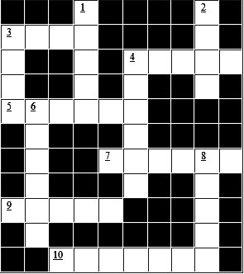

Clues
Down: 1.___ do you live? I live in New York.
Down: 2.Please leave the flowers in the garden. Don’t ___ them.
Across: 3.I ___ I could do that.
Down: 3.The opposite of cool is ___.
Across: 4.That is an old ___ and white TV.
Down: 4.The opposite of after is ___.
Across: 5.I wanted to go with him, but I had to go by ___.
Down: 6.Traffic lights are usually green, ___ and red.

Across: 7.This is a ___ flower.
Down: 8.Here, ___ and everywhere.
Across: 9.I ___ the money that I had lost.
Across: 10.I can’t read this ___ I have broken my glasses.

二、24点（每题0.2分，共2分）
1、 2 7 10 10 2、 3 7 7 8
3、 2 5 7 10 4、 3 6 6 8
5、 1 2 6 8 6、 1 7 8 9
7、 3 4 10 10 8、 1 3 5 10
9、 1 1 3 7 10、 2 3 4 9
三、成语谚语歇后语（每题0.2分，共4分）
第一级：根据成语写解释
- 不舞之鹤：
- 坐怀不乱：
- 多难兴邦：
- 白龙鱼服：
- 春风化雨：
第二级：补全歇后语（写在题目下方空白处）
- 丈八的灯台，_________
- 聋子放炮仗，_________
- ____________,手到拿来
- ____________,不知深浅
- ____________,略施小计
第三级：根据英文写出对应中文意思（成语、谚语、歇后语、名言）
- A good conscience is a soft pillow.

- Cheats never prosper.

- Do as you would be done by.

- Do it now.

- Creep before you walk.

第四级：补全英语谚语习语
- ______________ is the enemy of study.
- Content is better than ________.
- Business is __________.
- Be ______ to hear, slow to speak.
- Between friends all is _________.
4月28日中午1:00前由学习委员交到预初4班薛峥嵘、预初8班朱玮昊、初一6班柯慧怡、初二8班阮辰阳处或直接投入大队部门口的信箱里

