第十六周学习部小竞赛
姓名_______ 五位学号______成绩______(满分10分)
- English Crosswords（全对得6分，错1题倒扣0.1分）
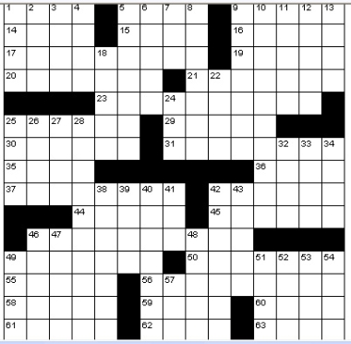
Across
1. African country 5. Guatemala natives
9. 50s ICBM 14. Hodgepodge
15. Verily 16. Alps-to-Arles river
17. “Fantasy Island” actor 19. Davis of Hollywood
20. In view 21. Red Baron, e.g.
23. Tough 25. Seismic effect
29. Sunder 30. English actor Leslie
31. Orchestra member 35. First name in daredevilry
36. Lawsuit 37. Clement
42. Italian brandy 44. Maine campus site
45. Passes on 46. Complex
49. Cold-blooded one 50. First
55. Wan 56. Burrowing mammal
58. Smart 59. Like workhorses
60. Big prefix 61. Components
62. Circle dance 63. Course concluder
Down
1. Pops’ partners 2. Century plant
3. Occupation 4. Minute amount
5. Wild duck 6. Fossil resin
7. Supporting vote 8. Poe’s ___ Lee
9. Decisive one 10. Histrionic
11. Lehmann or Lenya 12. Composer Bruckner
13. Crystal gazer 18. Despise
22. Start of a cheer 24. U.S. Army medal
25. That bunch 26. Be peripatetic
27. Ablutionary vessel 28. Dissatisfied person
32. California wine valley 33. Glimpse
34. Afternoon gatherings 38. Berlin and Stone
39. Dupe 40. Turn loose
41. Rawls or Reed 42. One of the Windward Islands
43. Performed again 46. Jai alai basket
47. Biblical land of riches 48. Malay Archipelago island
49. Abrade 51. Era
52. Holly 53. Primitive plant
54. Good soil 57. Pi follower
二、24点（每题0.4分，共4分）
1、 3 4 -6 10 2、 3 -5 7 -13

3、 1 -2 2 3 4、 3 -3 -2 8

5、 3 3 7 7 6、 2 -3 -5 4

7、 2 3 4 6 8、 1 3 12 -13

9、 7 1 4 9 10、 4 5 3 10
6月7日中午1:00前由学习委员交到预初4班薛峥嵘、预初8班朱玮昊、初一6班柯慧怡、初二8班阮辰阳处或直接投入大队部门口的信箱里

