第十四周学习部小竞赛
姓名_______ 五位学号______成绩______(满分10分)
- English Crosswords（全对得6分，错1题倒扣0.1分）
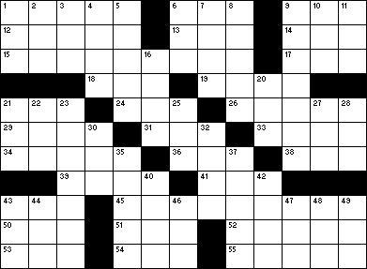
Across
1. "How _____ you say such a thing?"
6. Do something arthmetic
9. You might build a model from one
12. Musical that includes the song "Tomorrow"
13. US group that uses spies: Abbreviation
14. Large bird from Australia
15. The only president to be elected four times
17. Old, useless horse
18. It can follow "lemon" or "orange" in names of drinks
19. What Jack Sprat's wife couldn't eat
21. ____ Blanc (Man who did the voice of Bugs Bunny)
24. Taste a drink
26. Command to a dog
29. The opposide of good
31. Boy
33. A sword has a sharp one
34. They determine the color of your eyes, how tall you are, etc.
36. "You bet!"
38. Money used in Japan
39. Layer of paint
41. Had lunch
43. Scooby-___
45. President who wrote the Declaration of Independence
50. Bird that hoots
51. "Th-th-that's ___, folks!"
52. Beethoven's instrument
53. Perfect score in gymnastics
54. It opens a lock
55. Tunnel underneath a city
Down
1. Automobile
2. Yoko ___ (Japanese singer)
3. Card game and "Skip" and "Reverse" cards
4. One of the kids on "The Simpsons"
5. Ownership cards in Monopoly
6. Part of the royal flush, in poker
7. ____ pickle
8. Goes out with
9. The youngest person ever elected president
10. "____ little teapot ...": 2 words
11. Pull hard
16. What a bridge wears over her face
20. Larger relative of a monkey
21. One of the sisters in "Little WOmen"
22. Christmas ______
23. President during the US Civil War
25. "_____ attention"
27. It gets bigger on your birthday
28. Barbie's boyfriend
30. Zodiac sign whose symbol is a lion
32. Unable to hear
35. Pat ____ (the host of "Wheel of Fortune")
37. Parts of a staircase
40. What the T in TV stands for
42. One of the five Great Lakes
43. Wakko and Yakko's sister, on "Animaniacs"
44. Need to pay back
46. Ride in an airplane
47 Cutting tool
48. "I'm having ____ of those days"
49. Neither here ____ there
二、24点（每题0.4分，共4分）
1、 3 4 6 10 2、 3 5 7 13

3、 1 5 5 5 4、 3 3 7 7

5、 1 3 4 6 6、 3 3 8 8

7、 1 11 12 13 8、 4 4 10 10

9、 1 2 7 7 10、 7 8 8 10
5月24日中午1:00前由学习委员交到预初4班薛峥嵘、预初8班朱玮昊、初一6班柯慧怡、初二8班阮辰阳处或直接投入大队部门口的信箱里

